# Project: Product Shop

Product Shop is a system that registers users, categories, products and orders. It is a significantly big project, and as such it will have several parts. In this exercise you will land the basics of the application, in other words - the user functionality.

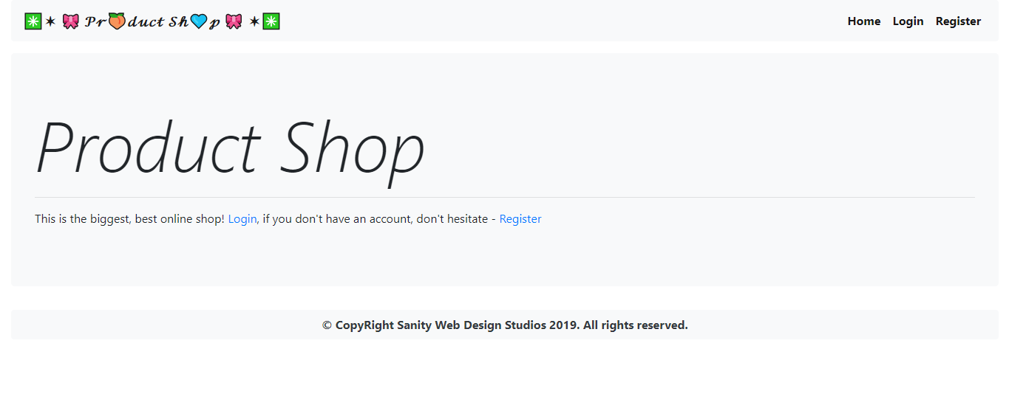

# Workshop: Part 3 - Orders

## Views

These are the additional views you must implement.

Add “**Order Product**” button into the product details page.

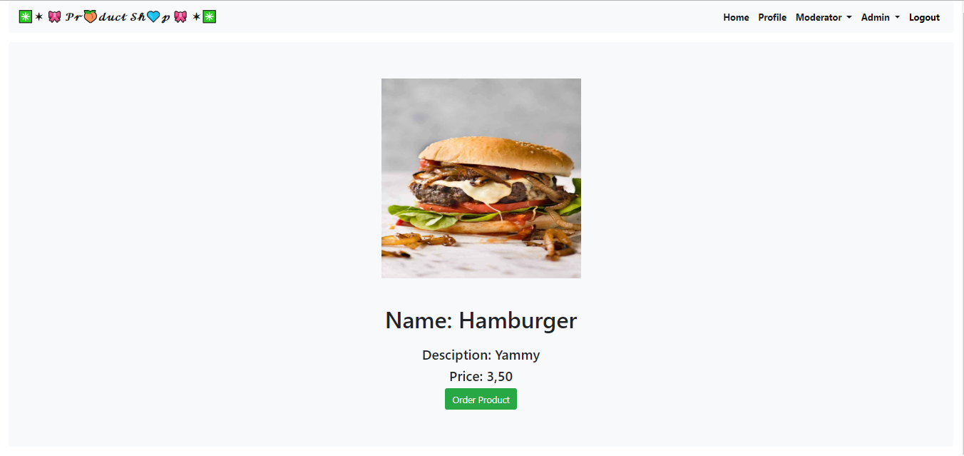

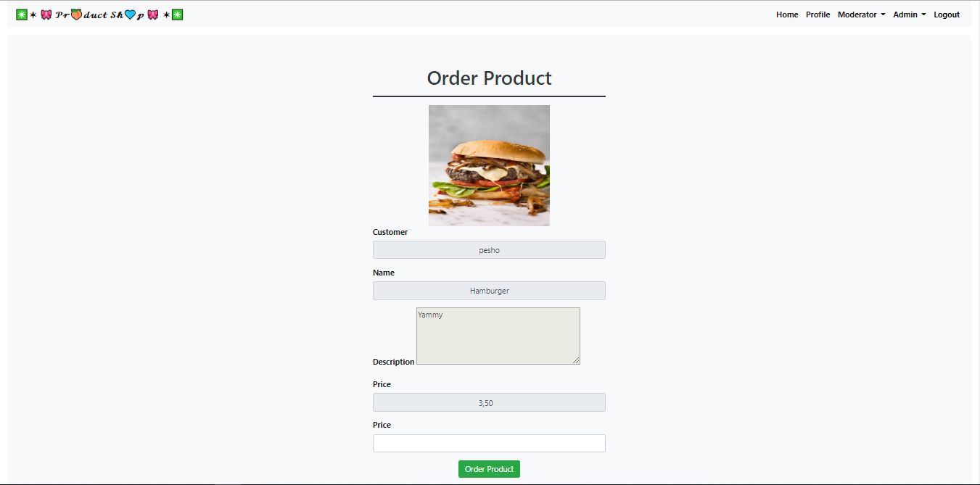

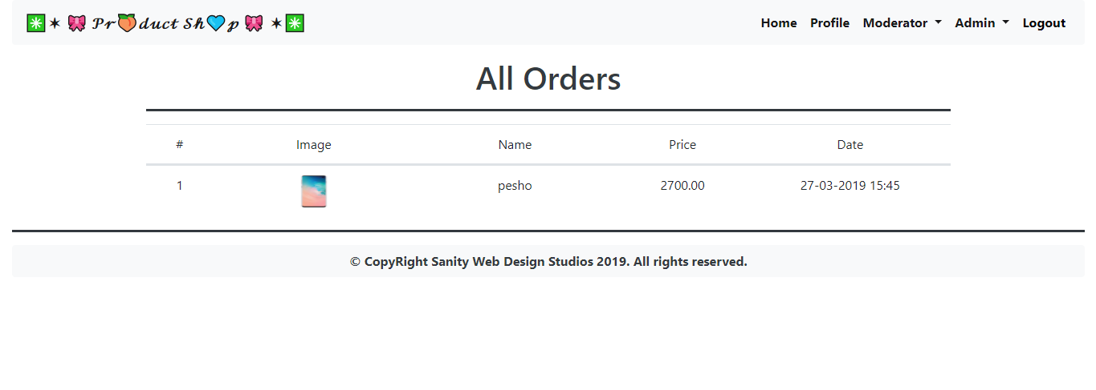

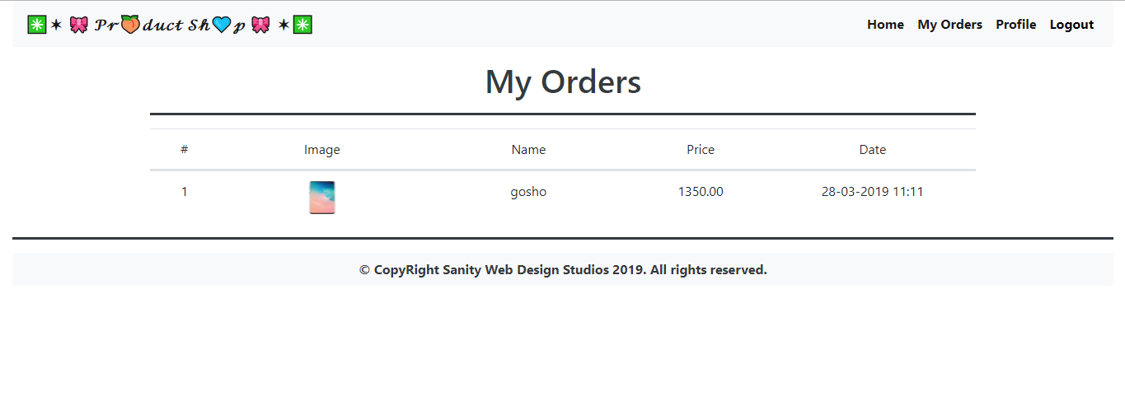

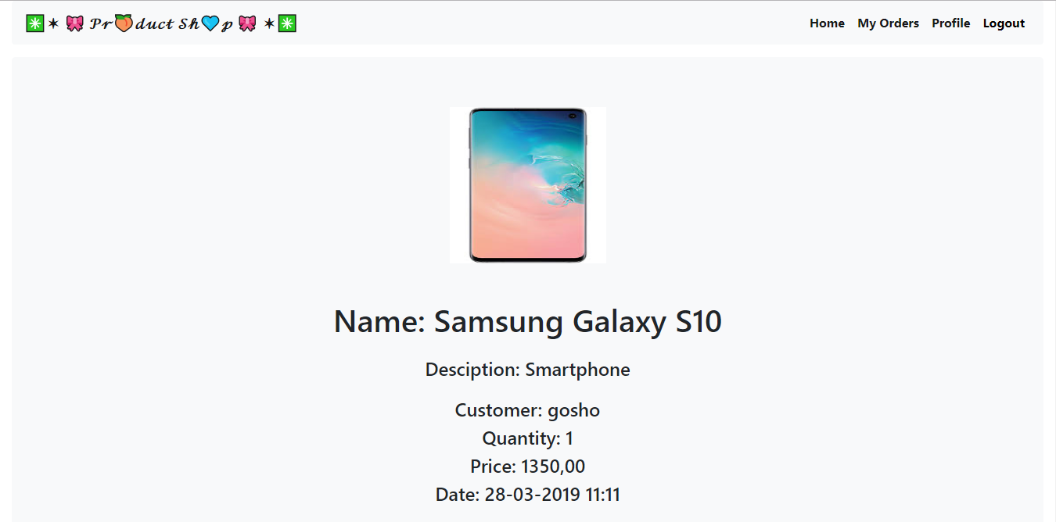

## Data Entities

Create the required **entities**. Use the appropriate **data types**. In this exercise you will have Users and their Roles

* **Product**
  + **Id –** primary key, universally unique identifier
  + **Product –** a product which is ordered
  + **Customer –** user who is ordering
  + **OrderDate** – date with time
  + **Quantity –** number
  + **TotalPrice –** decimal number

## Establish the Back-End

Create the required:

* **Entities**
* **Models**
* **Repositories**
* **Services**
* **Controllers**

## Functionality

### Order Product

Implement Order functionality.

### List User’s Orders

Implement a functionality that lists all orders made by the logged in user.

### List All Orders

For Admins only, implement List All Orders.

### Orders Details

Implement a page that shows details for a given order.